Dharma Devi-04/15-Assignment

Set Up Buckets Using Cloud Shell

• Using Cloud Shell, create three GCS buckets named:

• <your-username>-bronze

• <your-username>-silver

• <your-username>-gold

• Provide the gsutil commands you used.

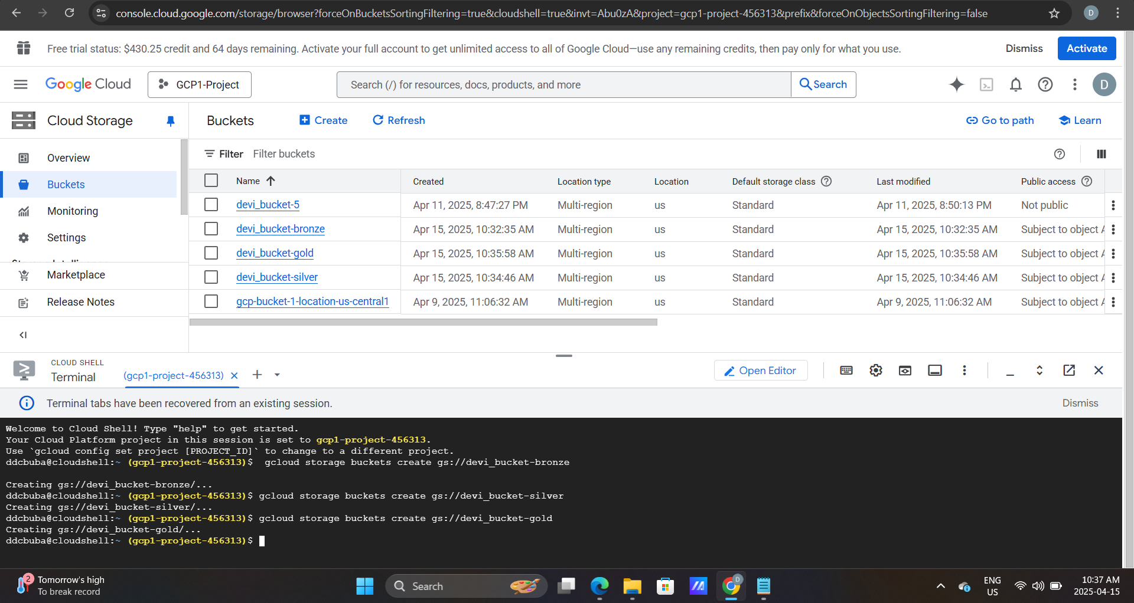

ddcbuba@cloudshell:~ (gcp1-project-456313)$ gcloud storage buckets create gs://devi_bucket-bronze

Creating gs://devi_bucket-bronze/...

ddcbuba@cloudshell:~ (gcp1-project-456313)$ gcloud storage buckets create gs://devi_bucket-silver

Creating gs://devi_bucket-silver/...

ddcbuba@cloudshell:~ (gcp1-project-456313)$ gcloud storage buckets create gs://devi_bucket-gold

Simulate Data Movement

• Upload a sample CSV file (can be dummy data) to the Bronze bucket using gsutil.

ddcbuba@cloudshell:~ (gcp1-project-456313)$ echo "id,name,score" > sample_data.csv echo "1,Alice,90" >> sample_data.csv echo "2,Bob,85" >> sample_data.csv echo "3,Charlie,95" >> sample_data.csv ddcbuba@cloudshell:~ (gcp1-project-456313)$ gsutil cp sample_data.csv gs://devi_bucket-bronze/ Copying <file://sample_data.csv> [Content-Type=text/csv]... / [1 files][ 47.0 B/ 47.0 B]

Operation completed over 1 objects/47.0 B.

ddcbuba@cloudshell:~ (gcp1-project-456313)$ gsutil ls gs://devi_bucket-bronze/ gs://devi_bucket-bronze/sample.txt gs://devi_bucket-bronze/sample_data.csv

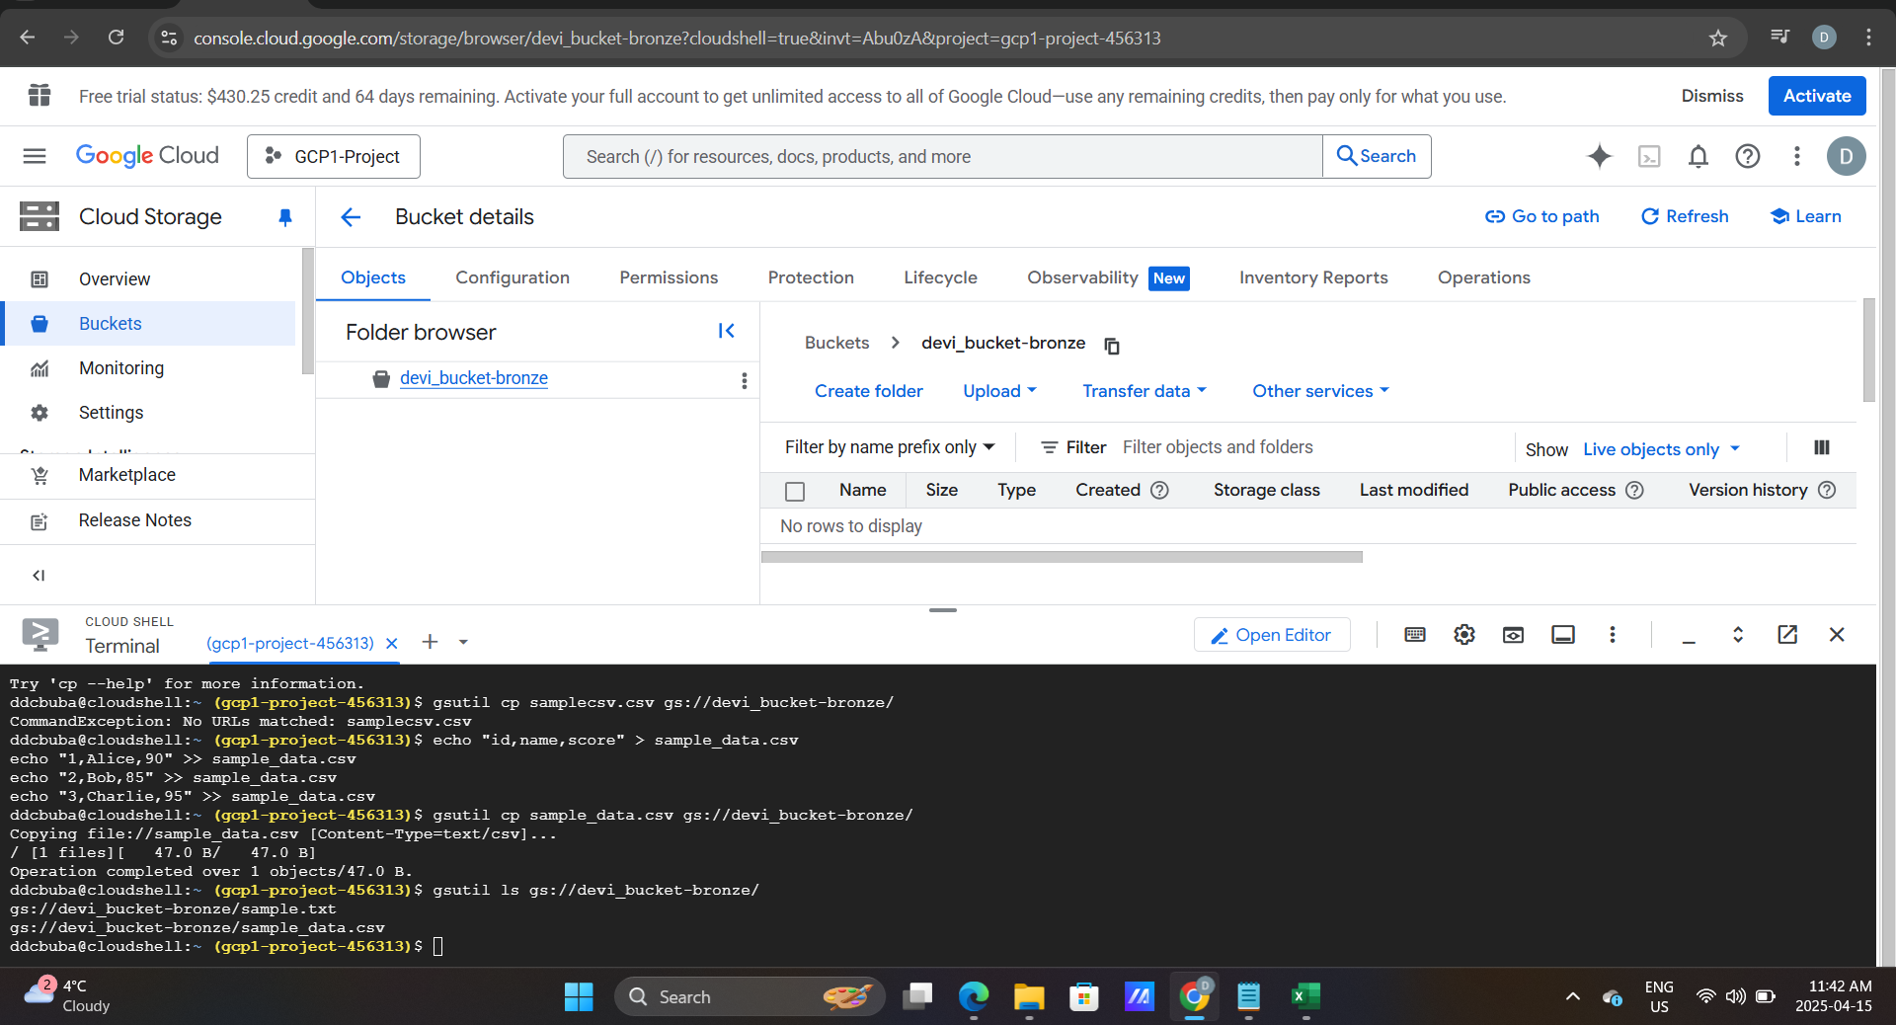

• Copy the file from Bronze to Silver, and then from Silver to Gold, using gsutil commands.

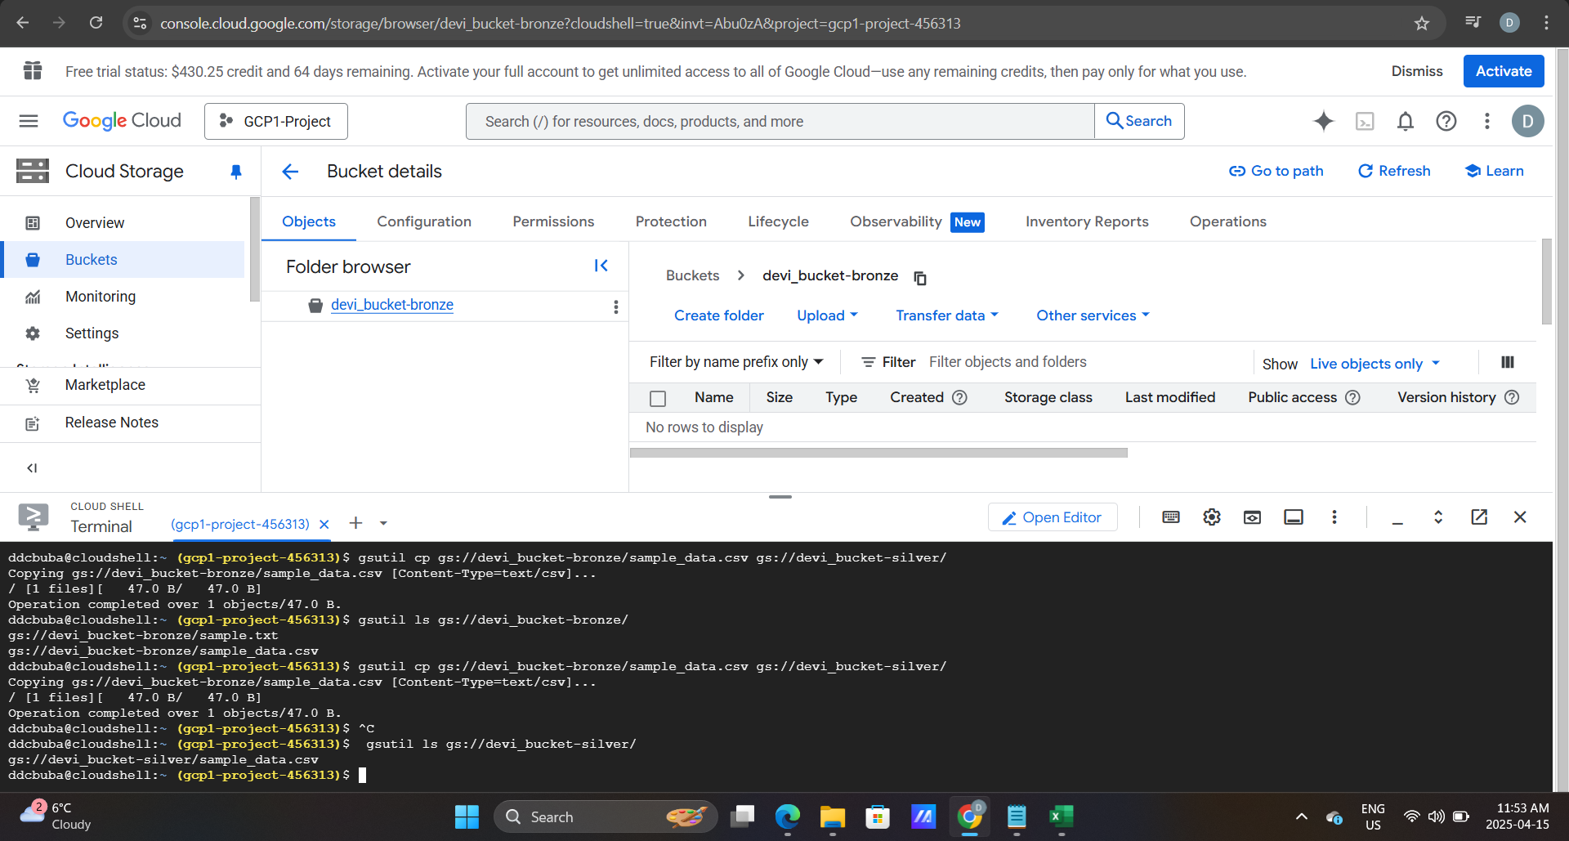

ddcbuba@cloudshell:~ (gcp1-project-456313)$ gsutil cp gs://devi_bucket-bronze/sample_data.csv gs://devi_bucket-silver/ Copying gs://devi_bucket-bronze/sample_data.csv [Content-Type=text/csv]... / [1 files][ 47.0 B/ 47.0 B]

Operation completed over 1 objects/47.0 B.

ddcbuba@cloudshell:~ (gcp1-project-456313)$ ^C ddcbuba@cloudshell:~ (gcp1-project-456313)$ gsutil ls gs://devi_bucket-silver/ gs://devi_bucket-silver/sample_data.csv ddcbuba@cloudshell:~ (gcp1-project-456313)$ gsutil cp gs://devi_bucket-silver/sample_data.csv gs://devi_bucket-gold/ Copying gs://devi_bucket-silver/sample_data.csv [Content-Type=text/csv]... / [1 files][ 47.0 B/ 47.0 B]

Operation completed over 1 objects/47.0 B.

ddcbuba@cloudshell:~ (gcp1-project-456313)$ ^C ddcbuba@cloudshell:~ (gcp1-project-456313)$ gsutil ls gs://devi_bucket-gold/ gs://devi_bucket-gold/sample_data.csv

